Stage 4 – And they will find the evidence of our cruelty
COURSE DESIGNER: Ike Starnes
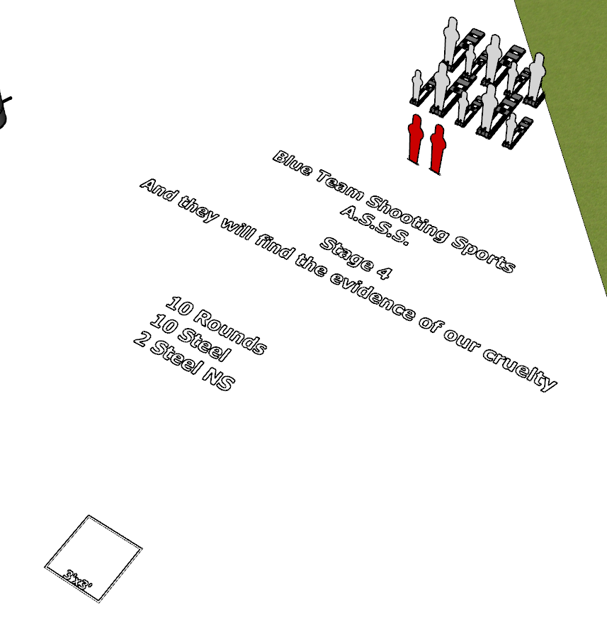

Written Stage Briefing:
Stage 4 – And they will find the evidence of our cruelty is a 10 round, 100 point, Comstock course. There are 10 steel targets and 2 steel No Shoot targets. The steel must fall to score.
Start position Both feet inside the shooting area.
Handgun: Loaded and holstered, wrists below belt
PCC: Loaded, stock touching belt
On the audible start signal, engage targets from within the shooting area.

